Test Case: tc003_SPX_Dev5_Validar_Funcionalidad_Botones_Add_Remove_Administrador_Roles_Menu
Step 1 - Enter username and password and click to button Enter : Credentials Entered
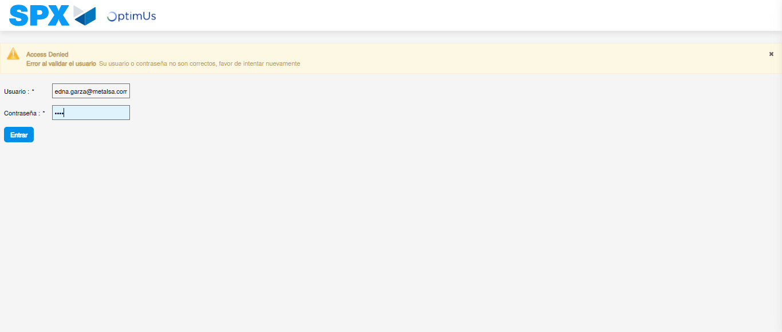Image file-name: QC_Testing-runTestMultipleTimes-nov. 20 2025, 01 53 35 p. m.

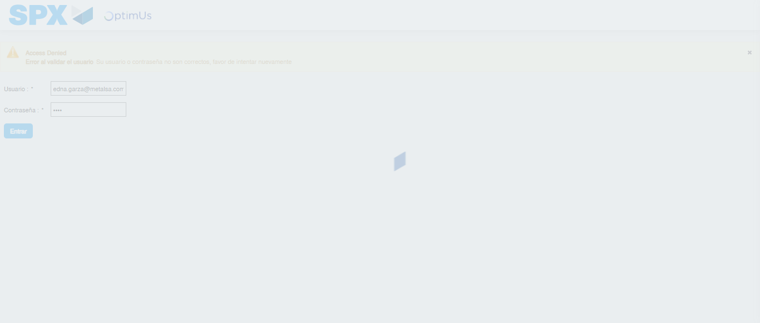Image file-name: QC_Testing-runTestMultipleTimes-nov. 20 2025, 01 53 36 p. m.

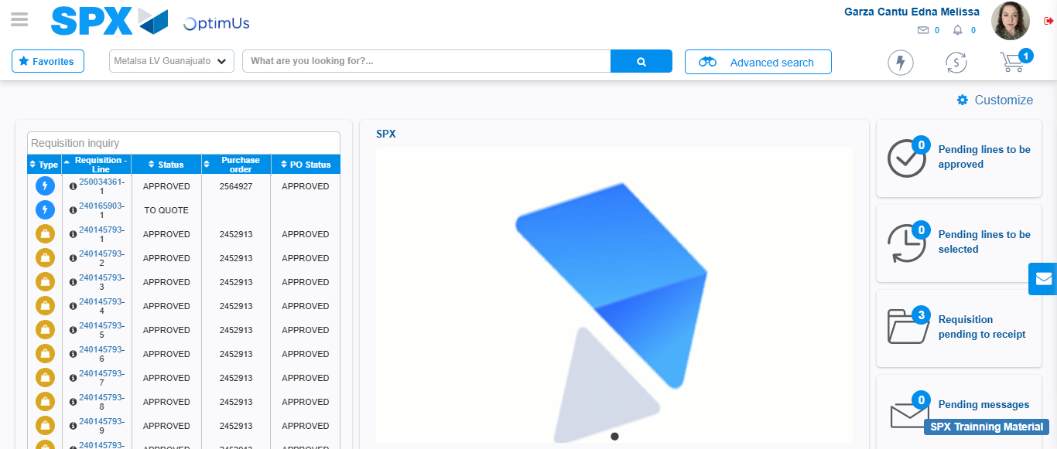Image file-name: QC_Testing-tc001_SPX_Dev5_Validar_Filtro_Campo_MenuName_Administrador_Roles_Menu-nov. 20 2025, 01 54 18 p. m.

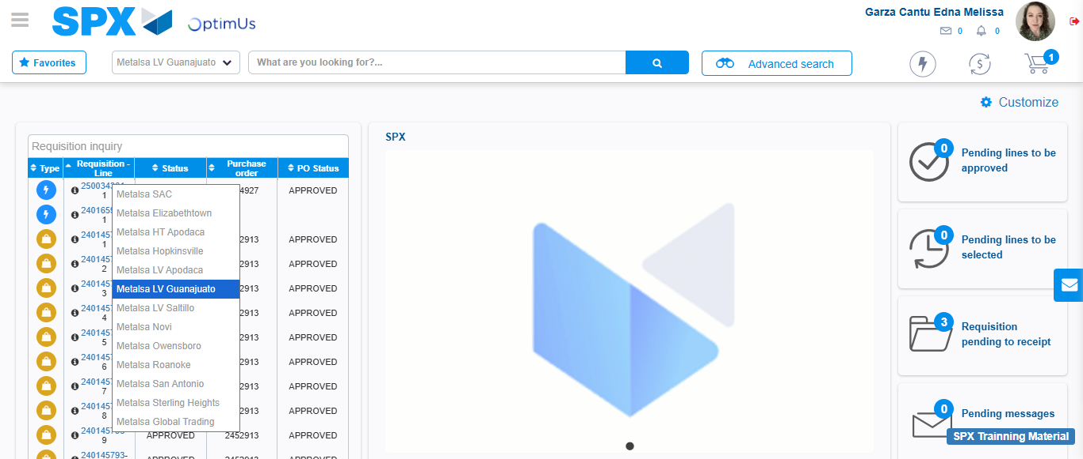Image file-name: QC_Testing-tc002_SPX_Dev5_Validar_Filtro_Campo_URLPath_Administrador_Roles_Menu-nov. 20 2025, 01 54 42 p. m.

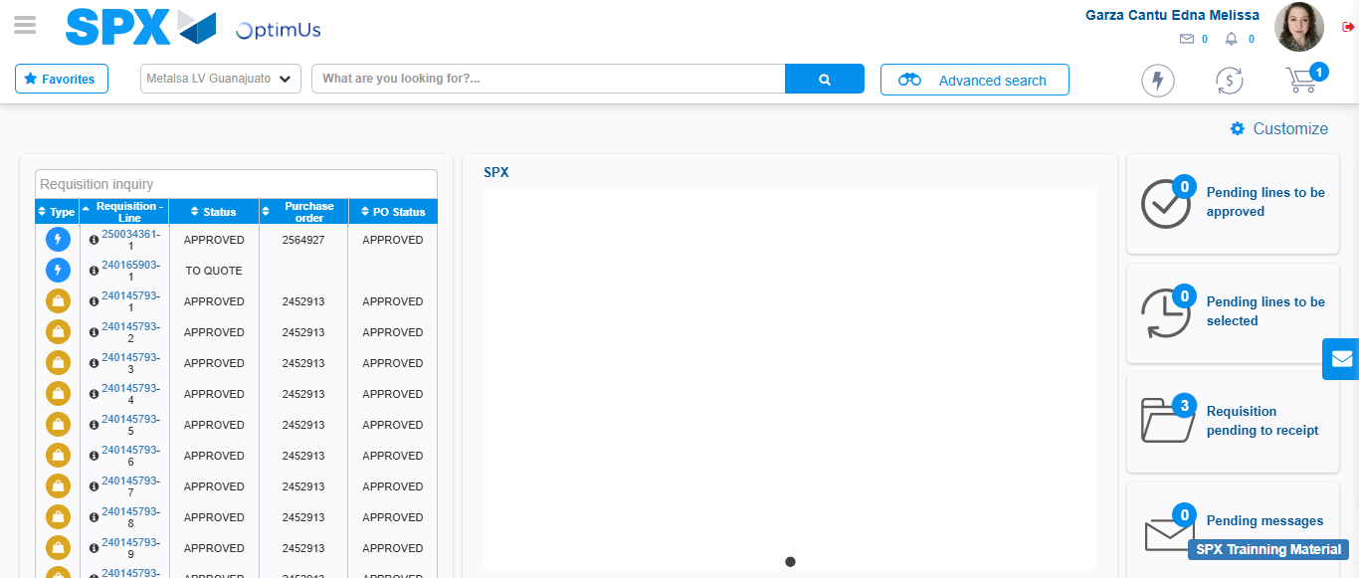Image file-name: QC_Testing-tc003_SPX_Dev5_Validar_Funcionalidad_Botones_Add_Remove_Administrador_Roles_Menu-nov. 20 2025, 01 55 10 p. m.

Step 2 - Select to UEN and Access to Administrador Roles Menu: UEN Correctly selected and Correct access
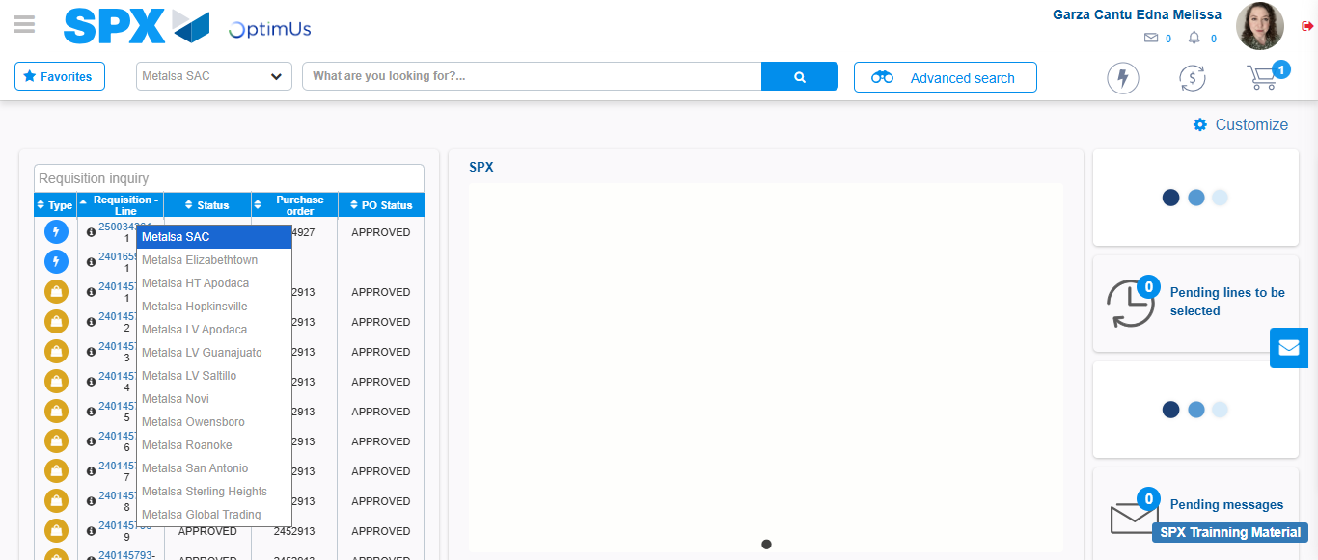Image file-name: QC_Testing-runTestMultipleTimes-nov. 20 2025, 01 53 45 p. m.

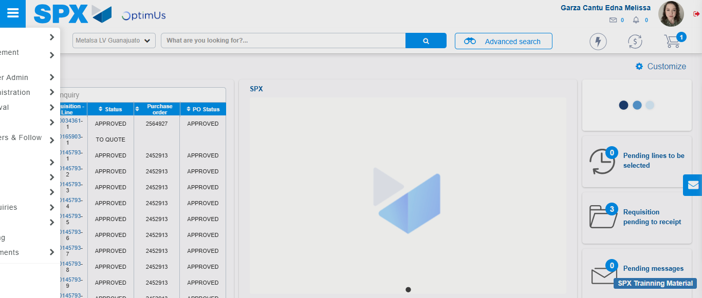Image file-name: QC_Testing-runTestMultipleTimes-nov. 20 2025, 01 53 46 p. m.

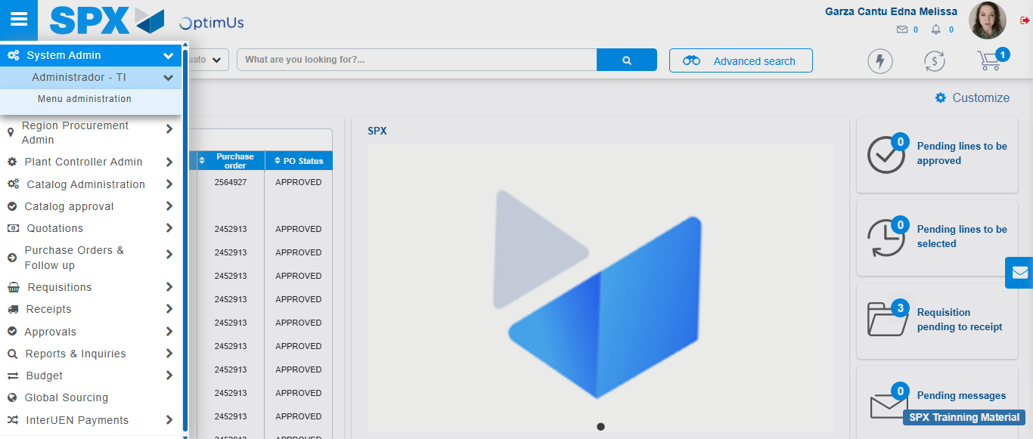Image file-name: QC_Testing-runTestMultipleTimes-nov. 20 2025, 01 53 47 p. m.

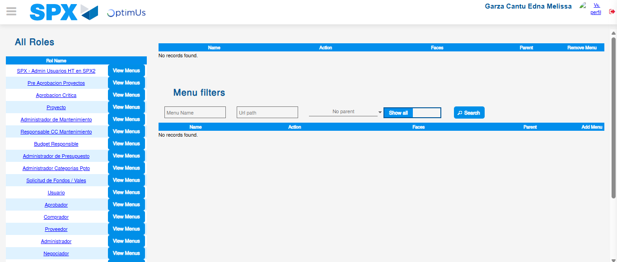Image file-name: QC_Testing-runTestMultipleTimes-nov. 20 2025, 01 53 51 p. m.

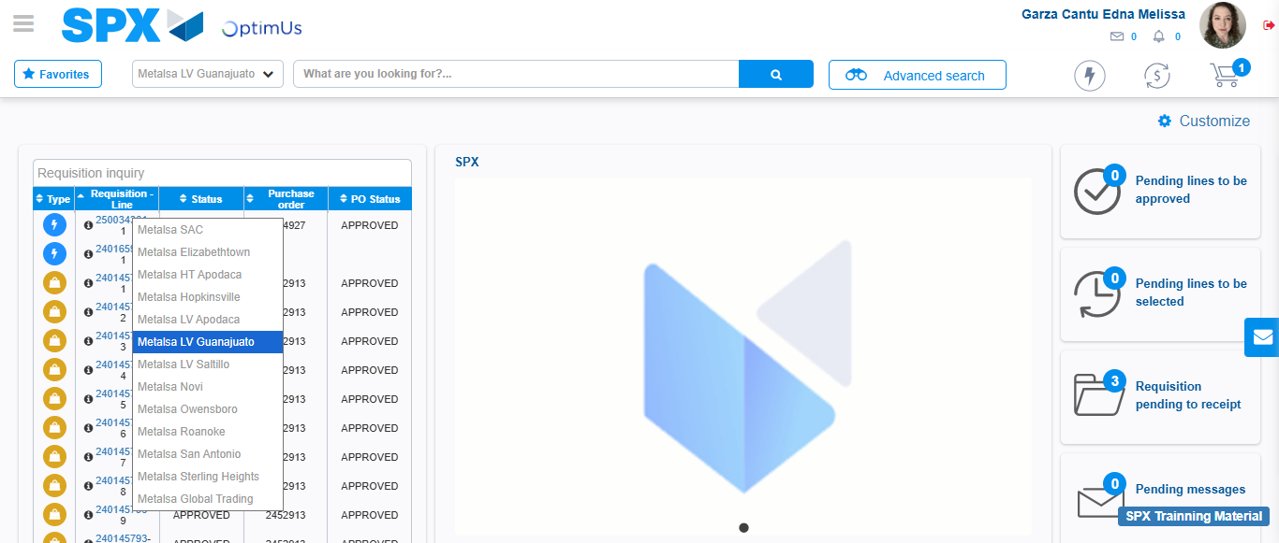Image file-name: QC_Testing-tc001_SPX_Dev5_Validar_Filtro_Campo_MenuName_Administrador_Roles_Menu-nov. 20 2025, 01 54 19 p. m.

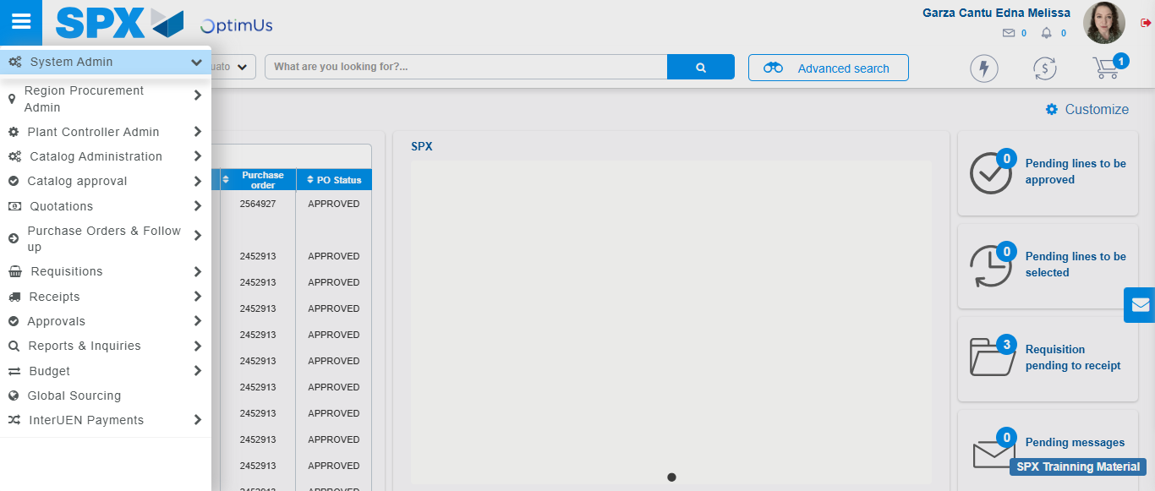Image file-name: QC_Testing-tc001_SPX_Dev5_Validar_Filtro_Campo_MenuName_Administrador_Roles_Menu-nov. 20 2025, 01 54 20 p. m.

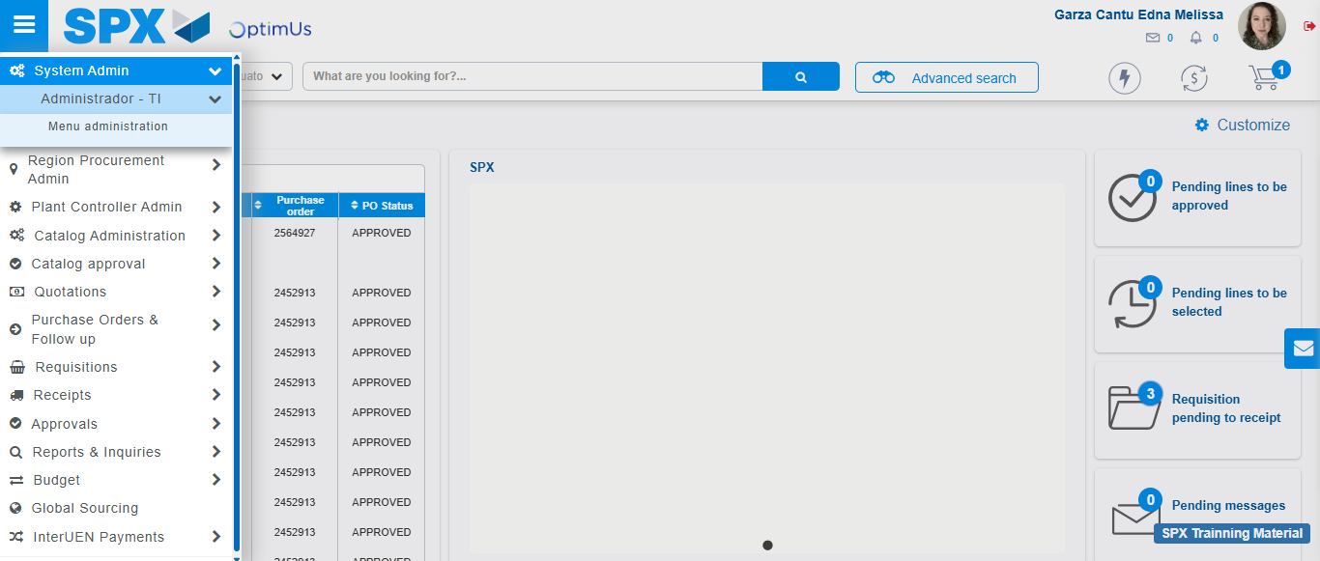Image file-name: QC_Testing-tc001_SPX_Dev5_Validar_Filtro_Campo_MenuName_Administrador_Roles_Menu-nov. 20 2025, 01 54 21 p. m.

Image file-name: QC_Testing-tc001_SPX_Dev5_Validar_Filtro_Campo_MenuName_Administrador_Roles_Menu-nov. 20 2025, 01 54 23 p. m.

Image file-name: QC_Testing-tc002_SPX_Dev5_Validar_Filtro_Campo_URLPath_Administrador_Roles_Menu-nov. 20 2025, 01 54 42 p. m.

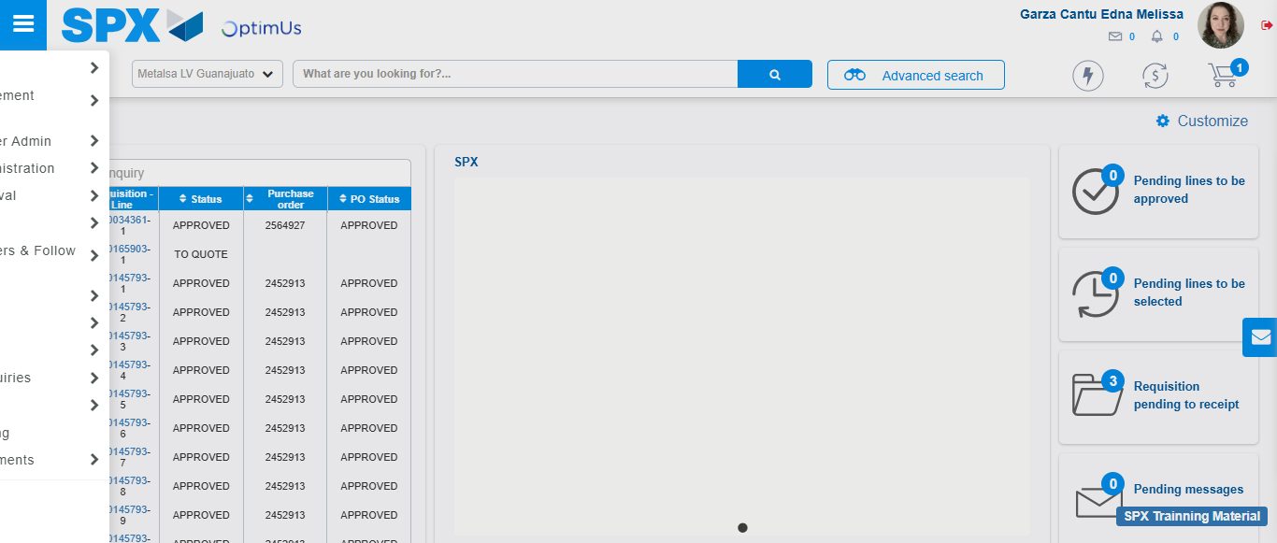Image file-name: QC_Testing-tc002_SPX_Dev5_Validar_Filtro_Campo_URLPath_Administrador_Roles_Menu-nov. 20 2025, 01 54 43 p. m.

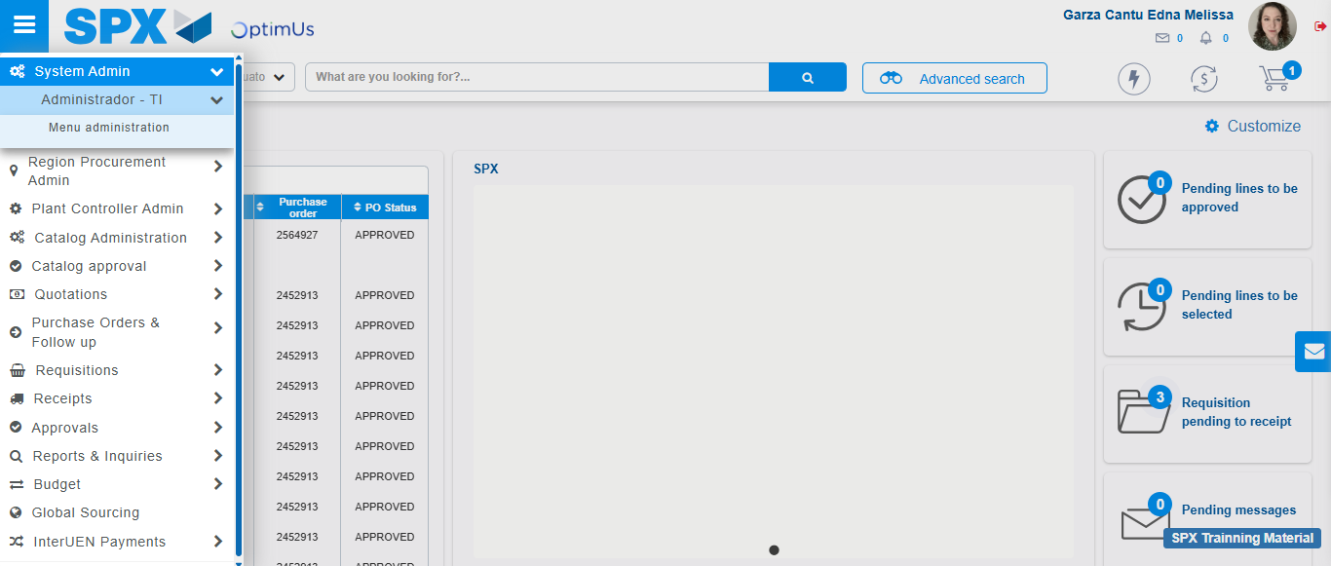Image file-name: QC_Testing-tc002_SPX_Dev5_Validar_Filtro_Campo_URLPath_Administrador_Roles_Menu-nov. 20 2025, 01 54 44 p. m.

Image file-name: QC_Testing-tc002_SPX_Dev5_Validar_Filtro_Campo_URLPath_Administrador_Roles_Menu-nov. 20 2025, 01 54 47 p. m.

Image file-name: QC_Testing-tc003_SPX_Dev5_Validar_Funcionalidad_Botones_Add_Remove_Administrador_Roles_Menu-nov. 20 2025, 01 55 10 p. m.

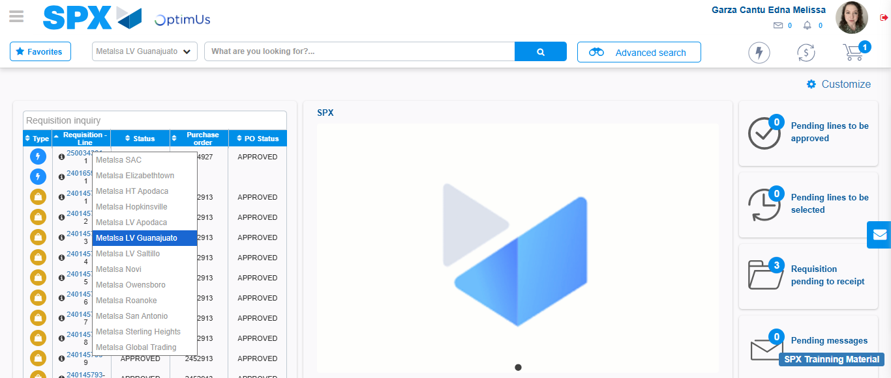Image file-name: QC_Testing-tc003_SPX_Dev5_Validar_Funcionalidad_Botones_Add_Remove_Administrador_Roles_Menu-nov. 20 2025, 01 55 11 p. m.

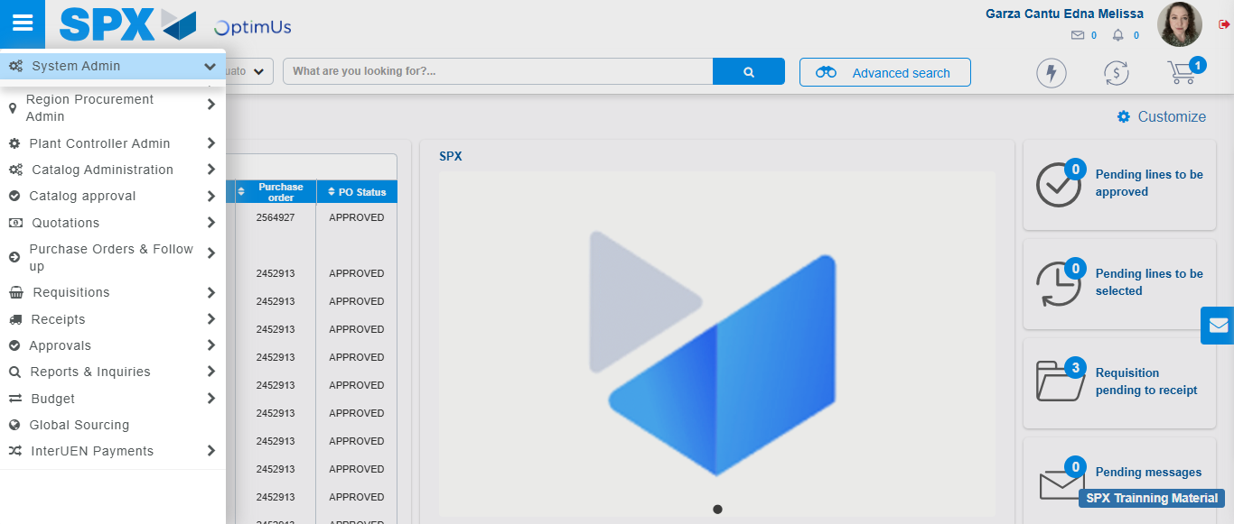Image file-name: QC_Testing-tc003_SPX_Dev5_Validar_Funcionalidad_Botones_Add_Remove_Administrador_Roles_Menu-nov. 20 2025, 01 55 12 p. m.

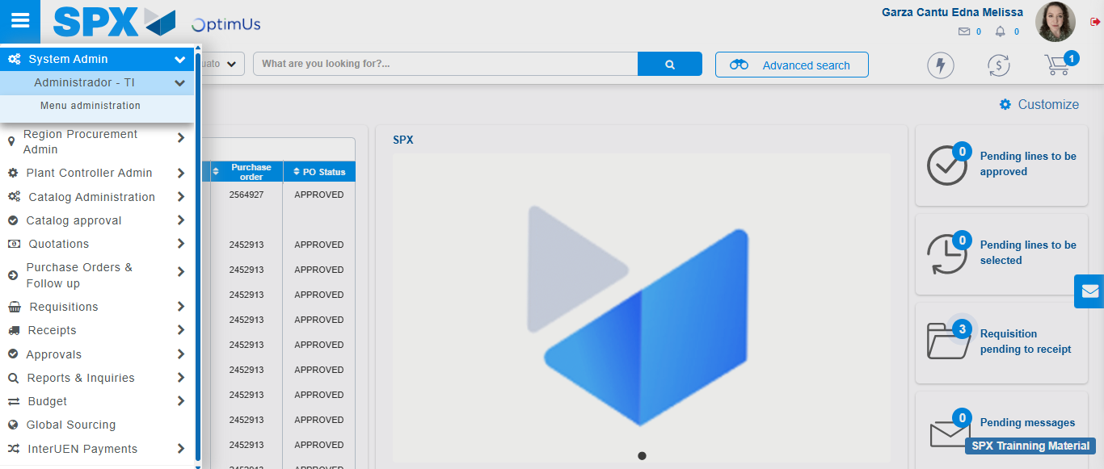Image file-name: QC_Testing-tc003_SPX_Dev5_Validar_Funcionalidad_Botones_Add_Remove_Administrador_Roles_Menu-nov. 20 2025, 01 55 13 p. m.

Image file-name: QC_Testing-tc003_SPX_Dev5_Validar_Funcionalidad_Botones_Add_Remove_Administrador_Roles_Menu-nov. 20 2025, 01 55 14 p. m.

Step 3 - Click to Buttons View Menu and Search Filter with Menu Name and Add new record and Delete Record: Correct Search and Record successfully added and Record successfully deleted
Image file-name: QC_Testing-runTestMultipleTimes-nov. 20 2025, 01 53 51 p. m.

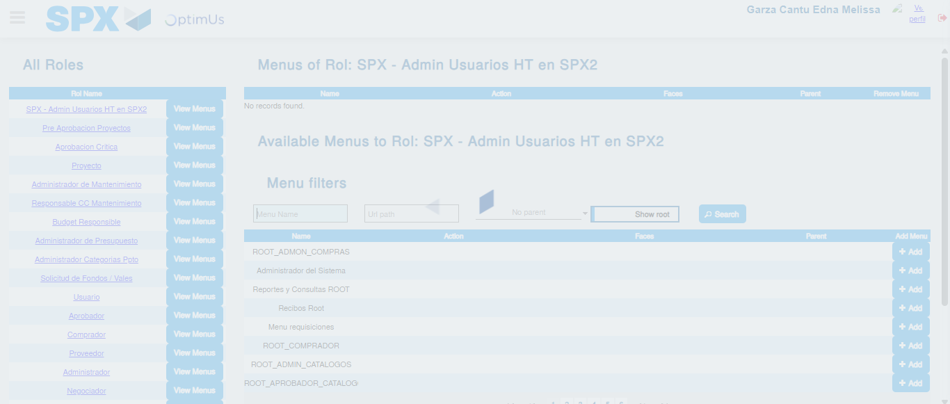Image file-name: QC_Testing-runTestMultipleTimes-nov. 20 2025, 01 53 52 p. m.

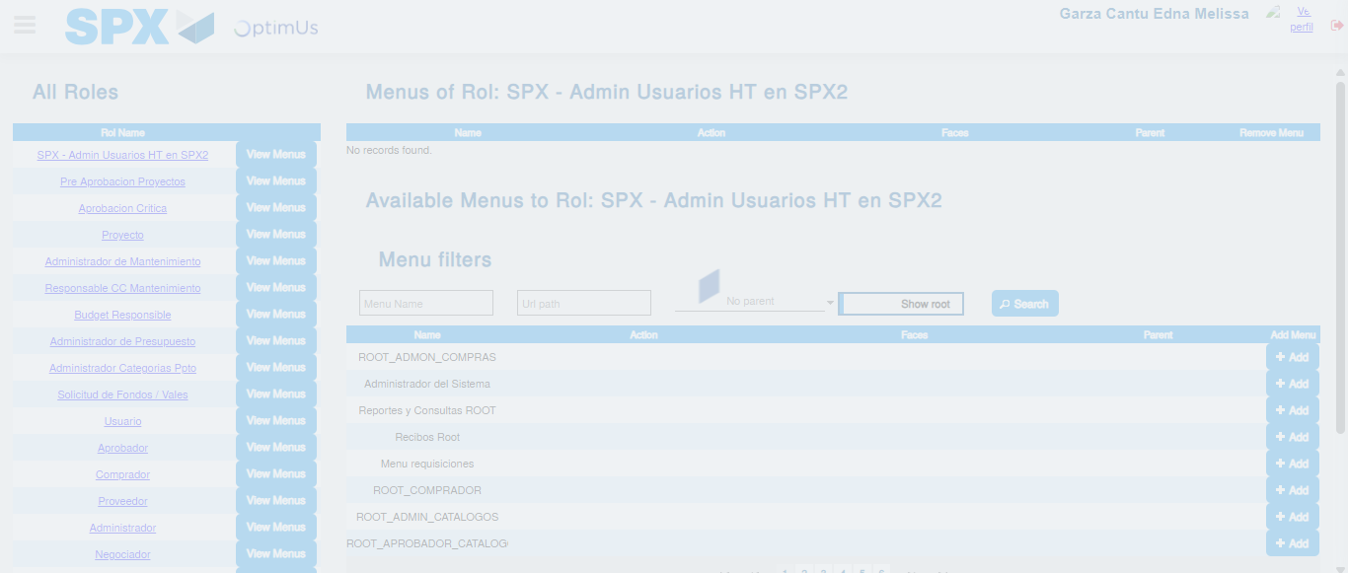Image file-name: QC_Testing-runTestMultipleTimes-nov. 20 2025, 01 53 53 p. m.

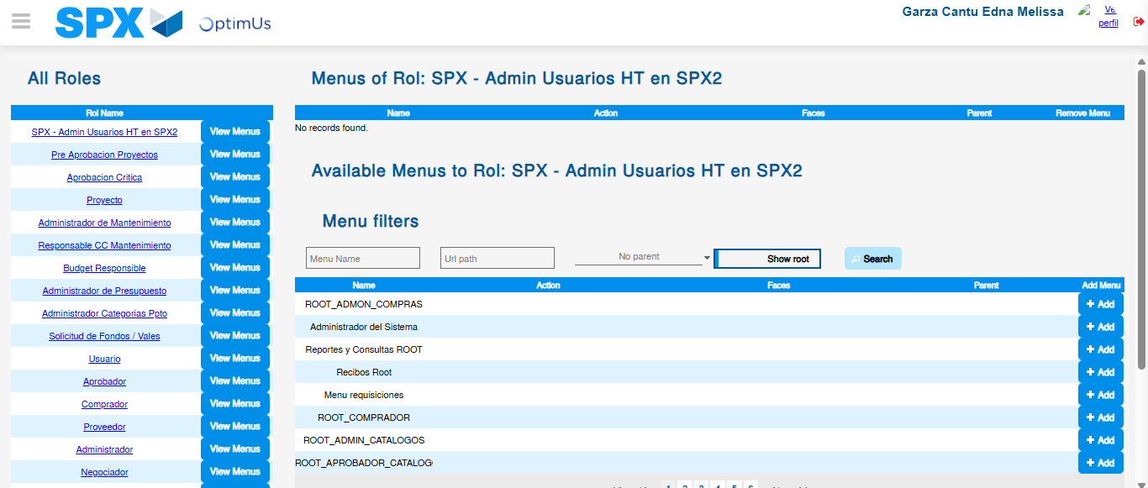Image file-name: QC_Testing-runTestMultipleTimes-nov. 20 2025, 01 54 04 p. m.

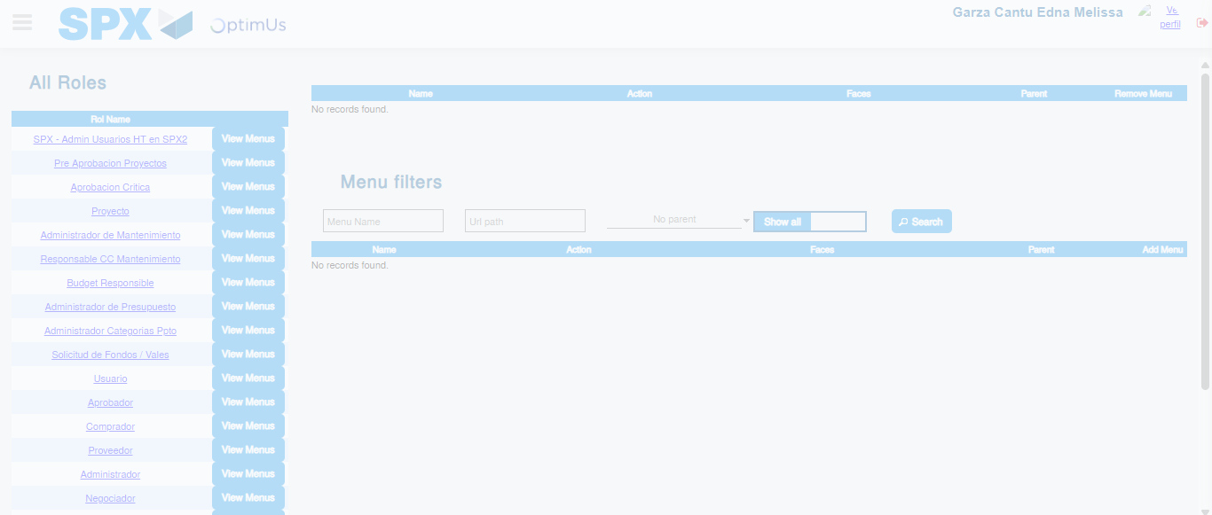Image file-name: QC_Testing-tc001_SPX_Dev5_Validar_Filtro_Campo_MenuName_Administrador_Roles_Menu-nov. 20 2025, 01 54 24 p. m.

Image file-name: QC_Testing-tc002_SPX_Dev5_Validar_Filtro_Campo_URLPath_Administrador_Roles_Menu-nov. 20 2025, 01 54 47 p. m.

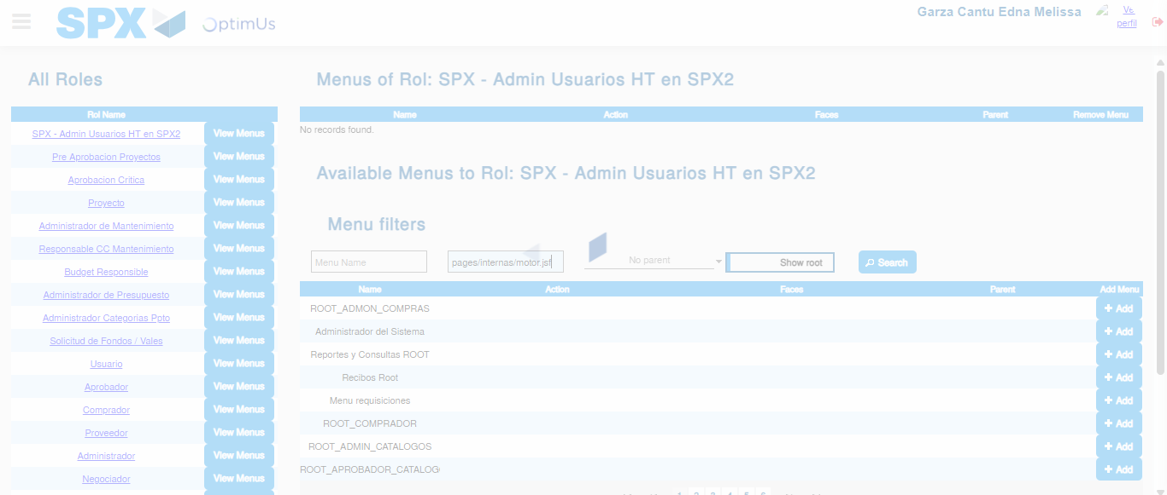Image file-name: QC_Testing-tc002_SPX_Dev5_Validar_Filtro_Campo_URLPath_Administrador_Roles_Menu-nov. 20 2025, 01 54 48 p. m.

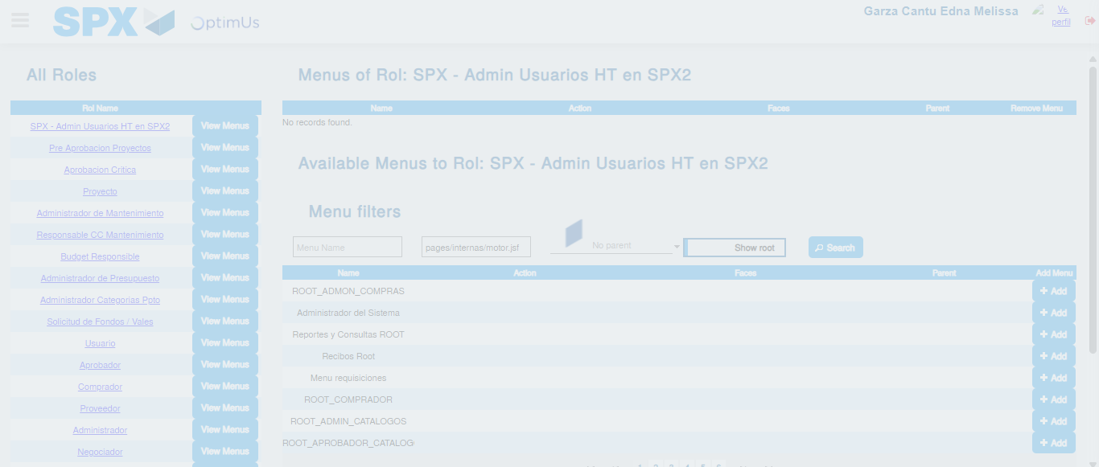Image file-name: QC_Testing-tc002_SPX_Dev5_Validar_Filtro_Campo_URLPath_Administrador_Roles_Menu-nov. 20 2025, 01 54 49 p. m.

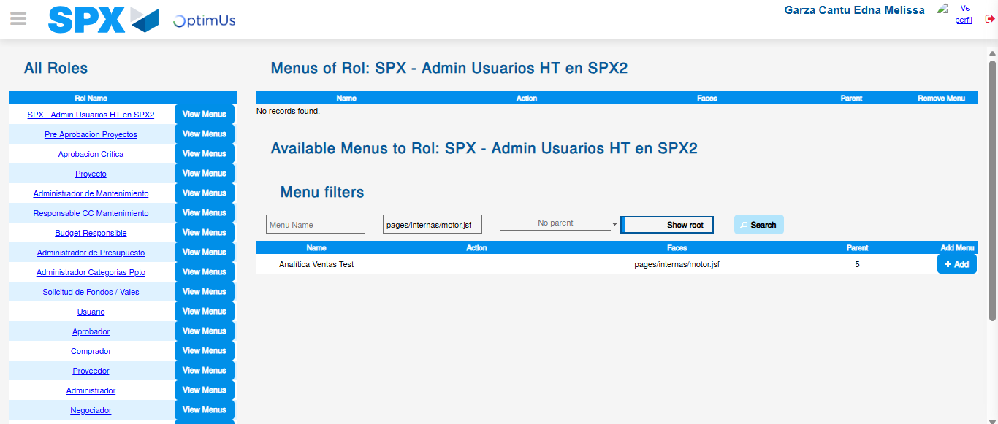Image file-name: QC_Testing-tc002_SPX_Dev5_Validar_Filtro_Campo_URLPath_Administrador_Roles_Menu-nov. 20 2025, 01 54 50 p. m.

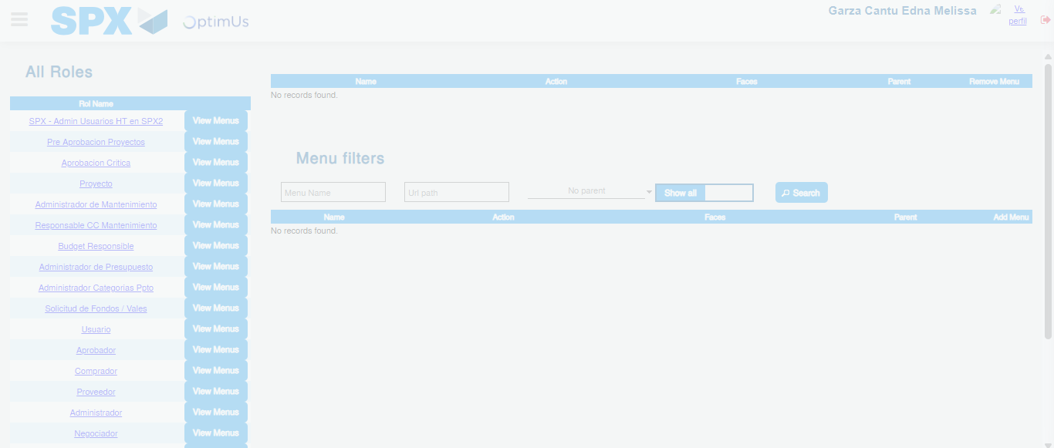Image file-name: QC_Testing-tc003_SPX_Dev5_Validar_Funcionalidad_Botones_Add_Remove_Administrador_Roles_Menu-nov. 20 2025, 01 55 15 p. m.

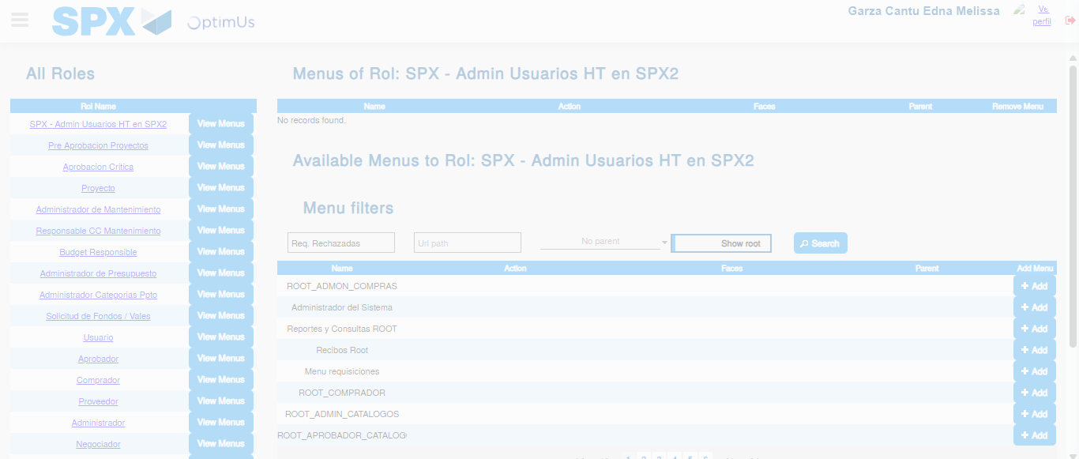Image file-name: QC_Testing-tc003_SPX_Dev5_Validar_Funcionalidad_Botones_Add_Remove_Administrador_Roles_Menu-nov. 20 2025, 01 55 16 p. m.

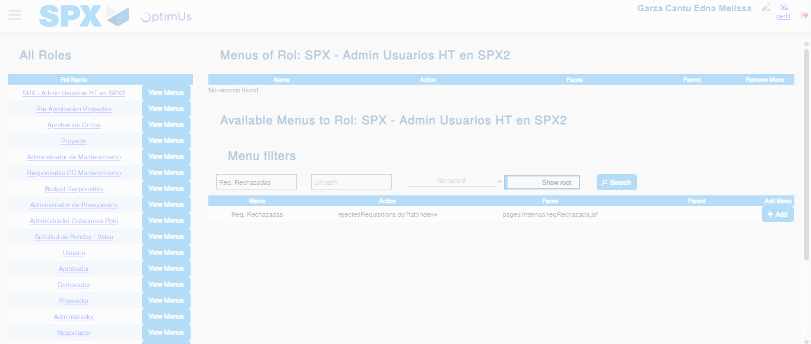Image file-name: QC_Testing-tc003_SPX_Dev5_Validar_Funcionalidad_Botones_Add_Remove_Administrador_Roles_Menu-nov. 20 2025, 01 55 17 p. m.

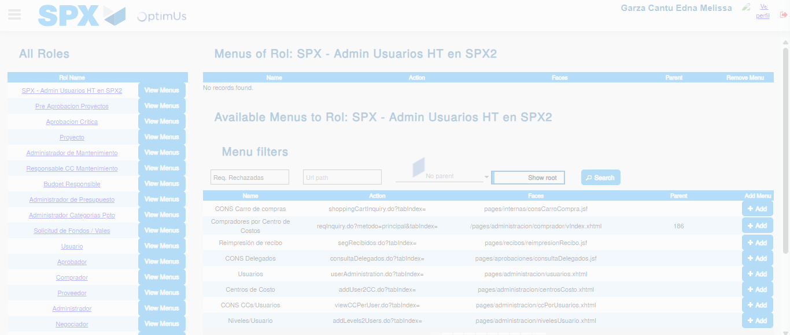Image file-name: QC_Testing-tc003_SPX_Dev5_Validar_Funcionalidad_Botones_Add_Remove_Administrador_Roles_Menu-nov. 20 2025, 01 55 21 p. m.

